Aethra troubleshooting:  
  
-To check system uptime[system]  
  
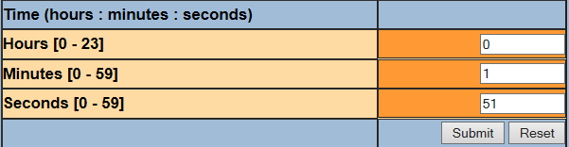  
  
-to change system password[system-password]  
  
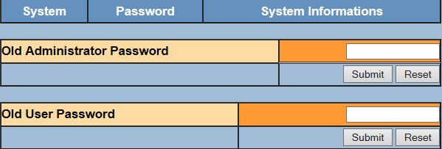  
  
-to check system information [system-system information]  
  
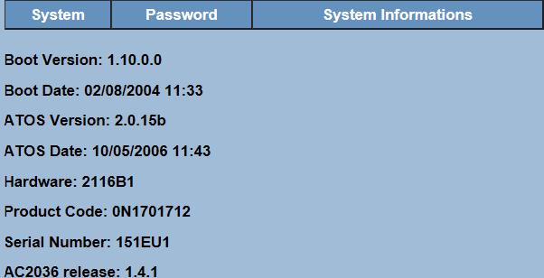  
  
  
-to restart modem remotely[main menu -restart]:  
  
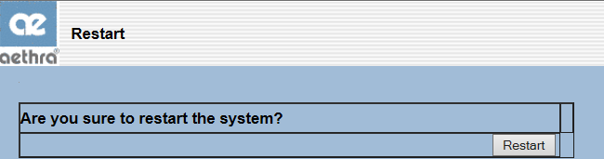  
to reset the modem to its factory setting [main menu –set default]  
  
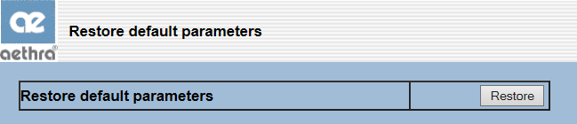  
to backup or restore configuration [main menu –upload/download] -  
  
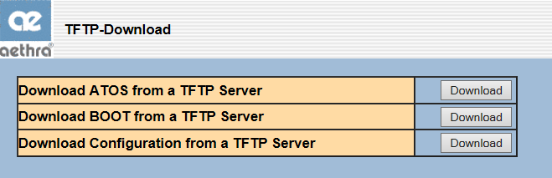  
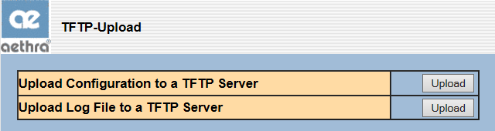  
  
  
to save configuration after any modification [main menu –save]-  
  
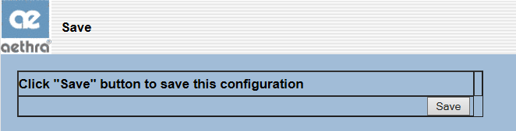

To check SNR margin and errors [SHDSL- show status]  
  
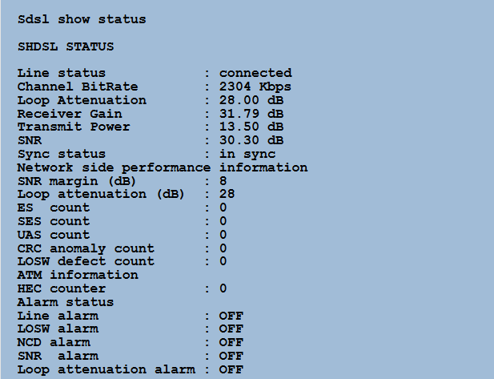  
  
To change clocking [SHDSL configuration]  
  
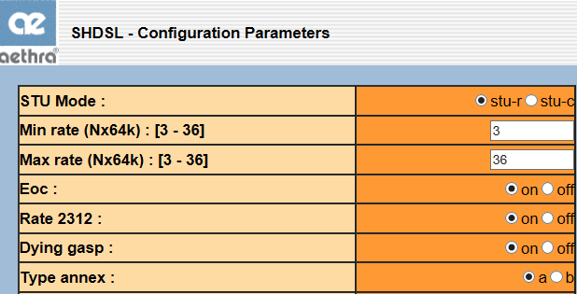  
  
-to check that LMI is physically up [serial- show status]  
  
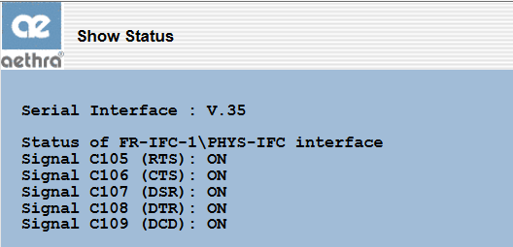

-To check serial speed [serial- configuration]

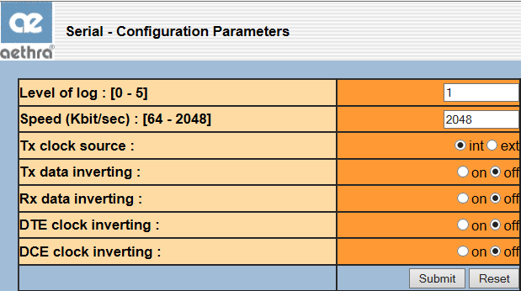  
  
-To check the LMI status [FRS IWF-show status]  
  
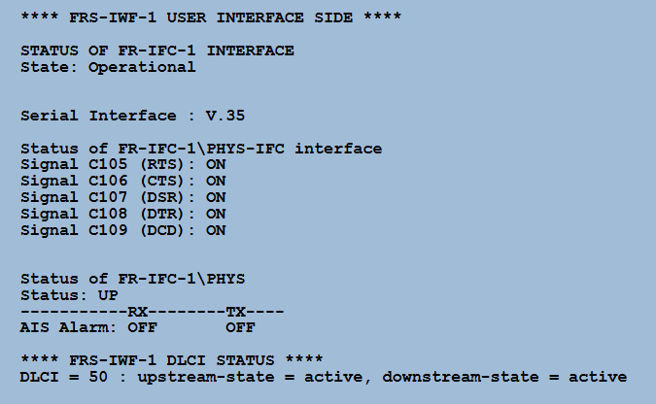  
  
 -to check the send and receive frames [FRS IWF-show statistics]  
  
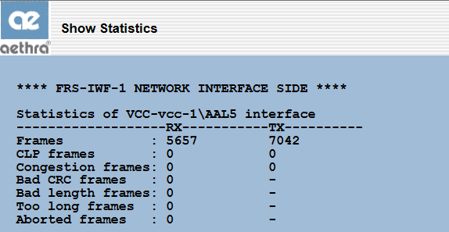

To test ATM ping [system utility-ATM ping]  
  
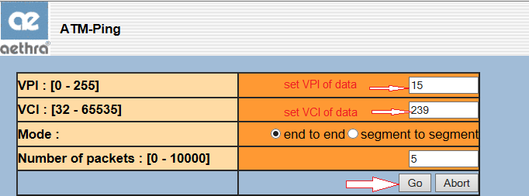  
  
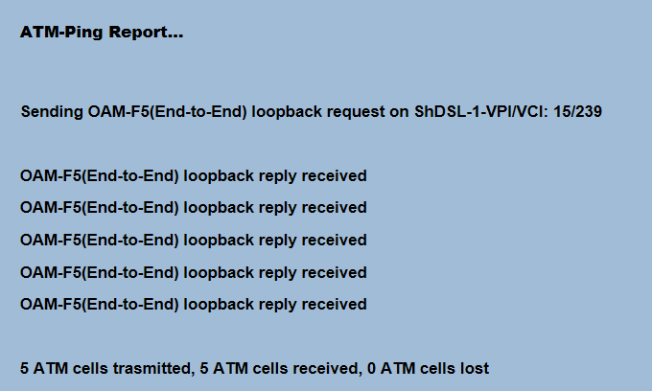

-to capture modem's logs [system utility –start log then stop log after a period of time then see the result ]  
  
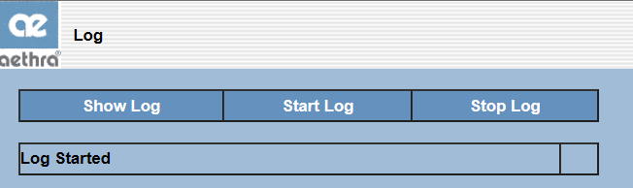

-to check the connectivity and the path to certain destination [ system utility-ping-trace]  
  
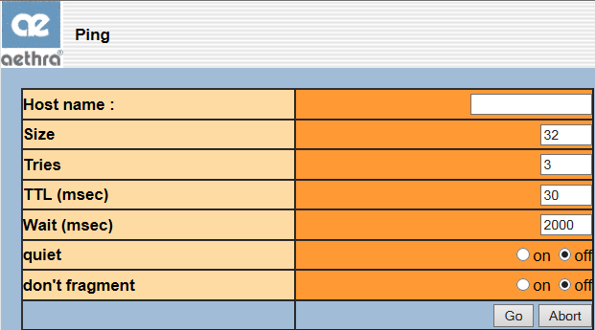

PartII- troubleshooting using command lines  
  
-To check system uptime[system]  
  


-to change system password[system-password]  


-to check system information [system-system information]  
  
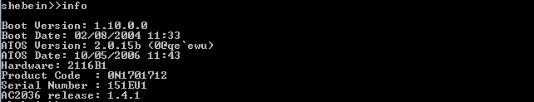

-to restart modem remotely[main menu -restart]:  
  


to reset the modem to its factory setting [main menu –set default]  
  


-to save configuration after any modification [main menu –save]  
  
 

To check SNR margin and errors [SHDSL- show status]

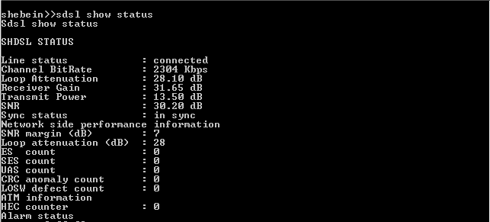

To change clocking [SHDSL configuration]  
  


-to check that LMI is physically up [serial- show status]  
  
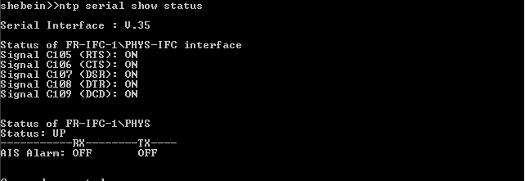

To check the LMI status [FRS IWF-show status]  
  
